29 October 2020

File Note: Biodiversity Net Gain Calculations for the proposed development at Ray Mill Road West

Ref: Biodiversity Net Gain (BNG) report

Site address: Ray Mill Road West, Maidenhead, Berkshire SL6 8SB

National Grid Reference: Centred on SU 8883 8187.

Site area: 0.219ha

Recipients: Royal Borough of Windsor & Maidenhead Property Company Ltd

Record of activity
- Background
Plowman Craven Limited were instructed by Royal Borough of Windsor & Maidenhead Property Company Ltd to undertake a Biodiversity Net Gain (BNG) evaluation of a development on the site, subject to a current planning application with Royal Borough of Windsor and Maidenhead Council (Ref. 19/02085/FULL).

- Purpose of survey
The purpose of the survey was to provide an evaluation of the proposed plans, to report any net gain to biodiversity using the DEFRA Biodiversity Metric 2.0 scheme.

- Surveyor and date of survey
This survey report was carried out by Joe Slade BSc (Hons) of Plowman Craven Ltd. on 29 October 2020. A previous Preliminary Ecological Appraisal is used as the baseline, completed in November 2018. The baseline habitat map and the proposed soft landscaping plans are found in appendix 1 and 2.

Summary findings
- The full results of the metric are included in the file:
2020 Biodiversity Metric 2.0 Calculation Tool (Ray Mill Road West)
- This highlights that the change in biodiversity units are:
- +~18% for habitat areas

- This is over a +10% net gain in biodiversity units, and is mainly contributed to the replacement of large areas of hard standing of the site including car parking areas with areas of amenity grass lawns, new tree planting and new native shrubs as boundaries between plots. The existing tree-lined hedgerow along the eastern boundary of the site is also retained unaltered.

Further Enhancement measures
- The developed site can be enhanced for bats by installing of a minimum of four bat boxes on mature trees around the site or the new buildings e.g. 2x Schwegler 1FD Bat Box 2x Schwegler 1FF Bat Box. Bat boxes should be positioned 3-5m above ground level facing south or south-westerly with a clear flight path to and from the entrance.
- Install three Schwegler bird boxes on retained trees or buildings on site e.g. Schwegler 1B nest boxes, Schwegler 2H Robin Boxes. Nest boxes should be positioned approximately 3m above ground level where they will be sheltered from prevailing wind, rain and strong sunlight. Small-hole boxes are best placed approximately 1-3m above ground on an area of the tree trunk where foliage will not obscure the entrance hole.
- Waste materials created during the development e.g. log piles, brash, rocks etc. can be used to create hibernacula and refugia for various species. These should be positioned on the site boundaries within communal garden areas.

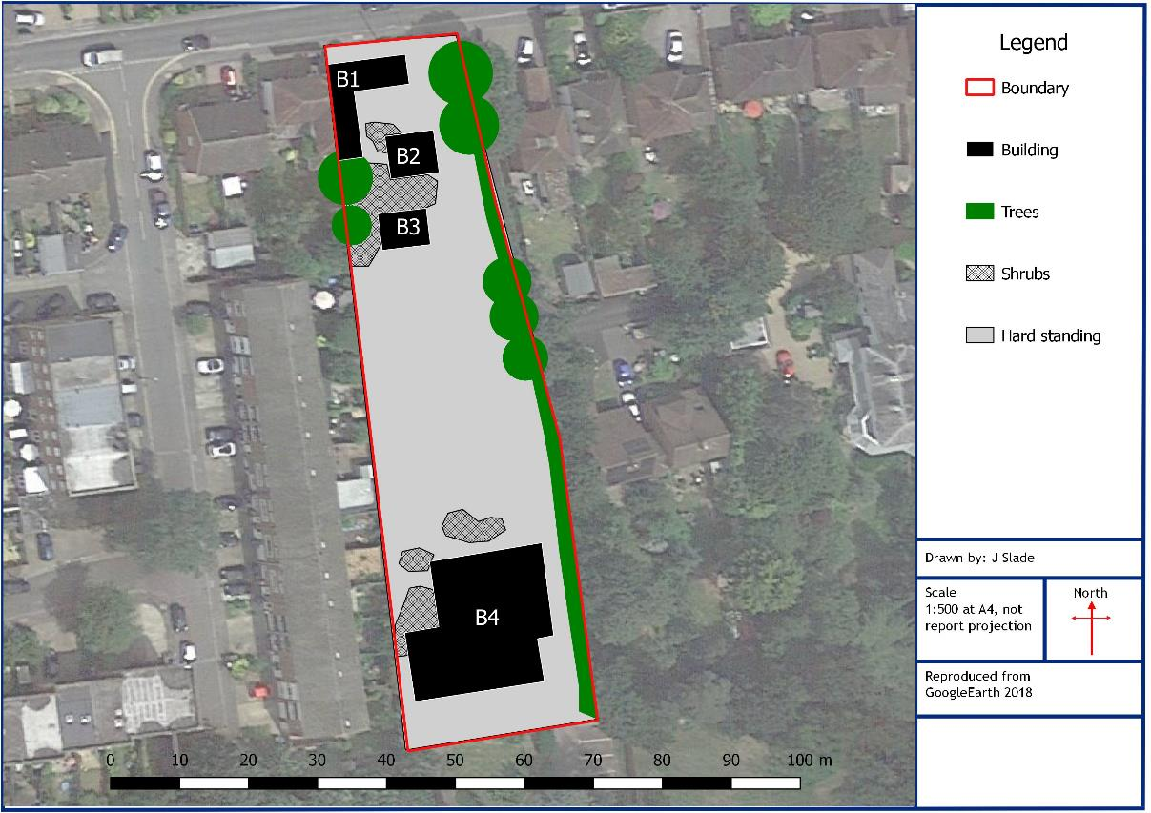
Appendix 1: Habitat baseline map

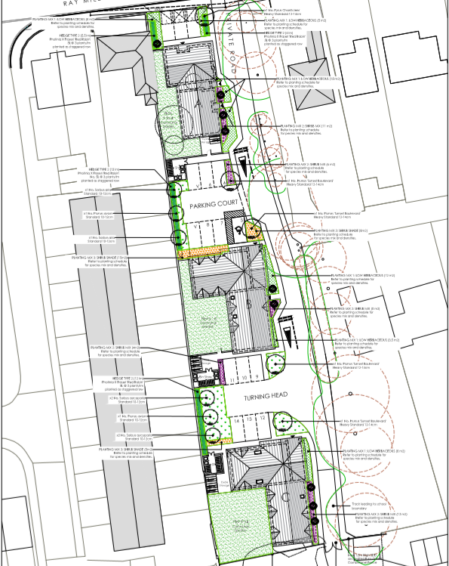
Appendix 2: Proposed soft landscaping map of the site

BACK PAGE

